

**CSCU9YM – Model Study Report**

Contents

**1** **Modeling the Traffic Jam** 2

**2** **Statement of hypothesis** 3

**2.1** **Hypothesis 1** 3

**2.1.1** **Table 1** 3

**2.1.2** **Table 2** 5

**2.2** **Hypothesis 2** 6

**3** **Statistical Analysis of ABM** 7

**3.1** **Number of Lanes** 7

**3.1.1** **Table 3** 7

**3.2** **Patience** 7

**3.2.1** **Table 4** 7

**3.3** **Acceleration** 8

**3.3.1** **Table 5** 8

**3.4** **Deceleration** 9

**3.4.1** **Table 6** 9

**3.5** **Number of Cars** 9

**3.5.1** **Table 7** 9

**4** **Conclusions** 10

# **Modeling the Traffic Jam**

A lot of people living in big cities like Los Angeles or New York City could end up spending the equivalent of three weeks per year stuck in traffic. Drivers know that accidents, construction, stall vehicles and just a large number of people on the road all contribute to traffic. The real culprit, however, is speed, or rather sudden random speed fluctuations. When drivers are travelling at a constant rate, traffic flows freely. But when even a single driver hits the breaks, the flow is interrupted, causing a chain reaction between the vehicles behind the driver. These vehicles must slowdown in order to avoid a collision and then speed back up to restore the previous flow. If the change in speed is not too drastic, this leads to what physicists call "synchronized flow." A traffic jam occurs when drivers break abruptly, causing the vehicles behind them to slow down or even stop. Vehicles enter the back of the traffic at a faster rate than slower moving lead vehicles can accelerate. As a result, the traffic jam persists until the volume of the incoming vehicles drops low enough to allow the lead vehicles to restore the flow.

Traffic can just appear, even with a single-lane highway with cars flowing until, for example, a chicken crosses the road, the driver who sees it breaks a little, the driver behind him does not immediately notice and breaks a little harder than necessary. Drivers behind him do the same until someone comes to a complete stop and the cars approaching highway speeds must stop now. On an imaginary ring-shaped road, a single car slowing down will start an Ouroboros traffic that will last forever, even though there is no road problem. If the drivers could coordinate to accelerate and separate at the same time, easy driving would return.

Now, in multi-lane highways, there's no need for chicken to start gridlock. A driver crossing the lanes quickly with cars too close behind, is enough to give birth to a traffic snake that lives for hours. It's this quick crossing that causes the drivers to over-break and start a chain reaction.

The underlying model simulates, as expected, the behavior of the cars when something blocks the road, which in this case is a random broken car or a slower car, and the results are visually clear, especially when the variable is set to a minimum or a maximum, e.g. Number of lanes or acceleration (Fig.1). This model is tested using the Behavior Space tool, using all the variable combinations for 1000 tick run with 5 repetitions (100,000 runs in total) which is more than enough to produce an appropriate result (Fig.3).

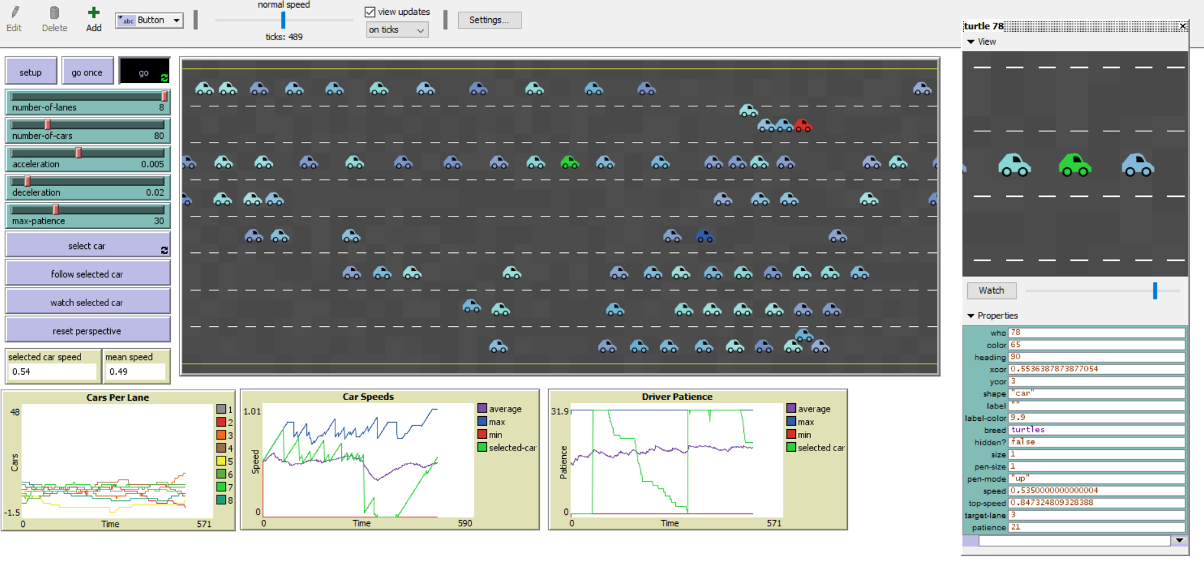

Figure 1: Running Model

# **Statement of hypothesis**

## **Hypothesis 1**

The first hypothesis concerns the most common question: can more roads solve the traffic problem? To answer this question from a traditional statistical point of view, we need to measure the Selected-Car's average speed that acts like all other cars, however, it is more effective and less volatile if we collect data from just one car that behaves like all others. For all our assumptions, we will test the car's overall speed, because logically, if the car's overall speed is high, that means there were fewer traffic jams. On the other hand, if the car's overall speed is low, it can be assumed that more and more traffic jams have occurred.

### **Table 1**

Summary Statistics (The lowest speed for cars is 0 and the maximum speed is 1.)

|  |  |  |  |  |  |  |  |  |  |
| --- | --- | --- | --- | --- | --- | --- | --- | --- | --- |
|  | **Lanes** | 1 | 2 | 3 | 4 | 5 | 6 | 7 | 8 |
| **Number of Cars** | **1** | 0.00 | 0.00 | 0.00 | 0.00 | 0.00 | 0.00 | 0.00 | 0.00 |
|  | **11** | 0.01 | 0.28 | 0.42 | 0.48 | 0.43 | 0.50 | 0.55 | 0.54 |
|  | **21** | 0.01 | 0.16 | 0.26 | 0.38 | 0.41 | 0.48 | 0.51 | 0.52 |
|  | **31** | 0.00 | 0.14 | 0.21 | 0.33 | 0.38 | 0.46 | 0.48 | 0.50 |
|  | **41** | 0.00 | 0.10 | 0.18 | 0.27 | 0.32 | 0.41 | 0.44 | 0.46 |
|  | **51** | 0.00 | 0.10 | 0.16 | 0.23 | 0.32 | 0.35 | 0.41 | 0.43 |
|  | **61** | 0.00 | 0.08 | 0.16 | 0.18 | 0.27 | 0.29 | 0.33 | 0.40 |
|  | **71** | 0.00 | 0.08 | 0.13 | 0.21 | 0.25 | 0.29 | 0.32 | 0.34 |
|  | **81** | 0.00 | 0.05 | 0.14 | 0.17 | 0.20 | 0.23 | 0.28 | 0.30 |
|  | **91** | 0.00 | 0.04 | 0.11 | 0.15 | 0.18 | 0.23 | 0.25 | 0.28 |
|  | **101** | 0.00 | 0.04 | 0.08 | 0.13 | 0.19 | 0.22 | 0.22 | 0.25 |
|  | **111** | 0.00 | 0.05 | 0.09 | 0.12 | 0.16 | 0.19 | 0.23 | 0.26 |
|  | **121** | 0.00 | 0.05 | 0.06 | 0.11 | 0.16 | 0.18 | 0.22 | 0.22 |
|  | **131** | 0.00 | 0.05 | 0.06 | 0.12 | 0.14 | 0.18 | 0.20 | 0.20 |
|  | **141** | 0.00 | 0.06 | 0.06 | 0.11 | 0.13 | 0.18 | 0.21 | 0.20 |
|  | **151** | 0.00 | 0.04 | 0.07 | 0.09 | 0.15 | 0.17 | 0.17 | 0.19 |
|  | **161** | 0.00 | 0.05 | 0.06 | 0.05 | 0.13 | 0.14 | 0.16 | 0.20 |
|  | **171** | 0.00 | 0.04 | 0.05 | 0.07 | 0.12 | 0.14 | 0.18 | 0.15 |
|  | **181** | 0.00 | 0.04 | 0.07 | 0.06 | 0.10 | 0.13 | 0.17 | 0.16 |
|  | **191** | 0.00 | 0.06 | 0.06 | 0.04 | 0.09 | 0.13 | 0.14 | 0.17 |
| **StdDev [speed] of selected-car** | **1** | 0.00 | 0.00 | 0.00 | 0.00 | 0.00 | 0.00 | 0.00 | 0.00 |
|  | **11** | 0.05 | 0.26 | 0.26 | 0.30 | 0.29 | 0.30 | 0.28 | 0.31 |
|  | **21** | 0.04 | 0.19 | 0.25 | 0.24 | 0.26 | 0.25 | 0.27 | 0.25 |
|  | **31** | 0.02 | 0.17 | 0.22 | 0.27 | 0.24 | 0.23 | 0.22 | 0.23 |
|  | **41** | 0.01 | 0.15 | 0.20 | 0.23 | 0.24 | 0.25 | 0.23 | 0.22 |
|  | **51** | 0.01 | 0.15 | 0.17 | 0.21 | 0.22 | 0.22 | 0.22 | 0.23 |
|  | **61** | 0.02 | 0.11 | 0.15 | 0.17 | 0.21 | 0.21 | 0.23 | 0.23 |
|  | **71** | 0.01 | 0.11 | 0.15 | 0.18 | 0.20 | 0.21 | 0.22 | 0.24 |
|  | **81** | 0.01 | 0.08 | 0.16 | 0.16 | 0.18 | 0.21 | 0.20 | 0.22 |
|  | **91** | 0.01 | 0.07 | 0.12 | 0.15 | 0.17 | 0.18 | 0.20 | 0.22 |
|  | **101** | 0.00 | 0.08 | 0.11 | 0.13 | 0.16 | 0.19 | 0.20 | 0.20 |
|  | **111** | 0.01 | 0.07 | 0.12 | 0.12 | 0.17 | 0.17 | 0.19 | 0.21 |
|  | **121** | 0.01 | 0.08 | 0.07 | 0.12 | 0.15 | 0.17 | 0.17 | 0.19 |
|  | **131** | 0.01 | 0.08 | 0.09 | 0.13 | 0.14 | 0.15 | 0.16 | 0.17 |
|  | **141** | 0.01 | 0.08 | 0.08 | 0.11 | 0.13 | 0.15 | 0.17 | 0.16 |
|  | **151** | 0.01 | 0.07 | 0.10 | 0.09 | 0.14 | 0.14 | 0.15 | 0.17 |
|  | **161** | 0.00 | 0.08 | 0.11 | 0.07 | 0.13 | 0.14 | 0.14 | 0.18 |
|  | **171** | 0.01 | 0.08 | 0.07 | 0.10 | 0.13 | 0.14 | 0.15 | 0.14 |
|  | **181** | 0.00 | 0.06 | 0.13 | 0.09 | 0.11 | 0.13 | 0.15 | 0.16 |
|  | **191** | 0.01 | 0.08 | 0.08 | 0.07 | 0.11 | 0.12 | 0.12 | 0.14 |

Figure 2: Graph of Average Speed of Selected-Car vs Number of Lanes

Figure 2 shows the average speed of the selected car on the Y axis, the number of lanes on the X axis and the number of cars for each run of the model. It looks a bit confusing at first, but it is really easy to understand. Take, for example, the "Number of Cars–11" (brown color) which means that there were 11 cars on that specific run. We can clearly see that the average speed of the car was getting higher and higher when more lanes were added, with only 11 cars flowing. Moreover, we can see that the average speed of "Number of Cars–1" is always zero. This happens because the model is programmed to always have one random car broken down at zero speed, hence, the chosen car is always broken as it is the only car running. Therefore, the average speed is always zero. For all hypotheses, the following parameters were used (Fig.3 and Table 2):

### **Table 2**

|  |  |  |  |
| --- | --- | --- | --- |
| Variable | Starts from | Increment by | End |
| Number-of-Lanes | 1 | 1 | 8 |
| Max-Patience | 1 | 20 | 100 |
| Acceleration | 0.002 | 0.002 | 0.01 |
| Deceleration | 0.02 | 0.02 | 0.1 |
| Number-of-Cars | 1 | 20 | 200 |

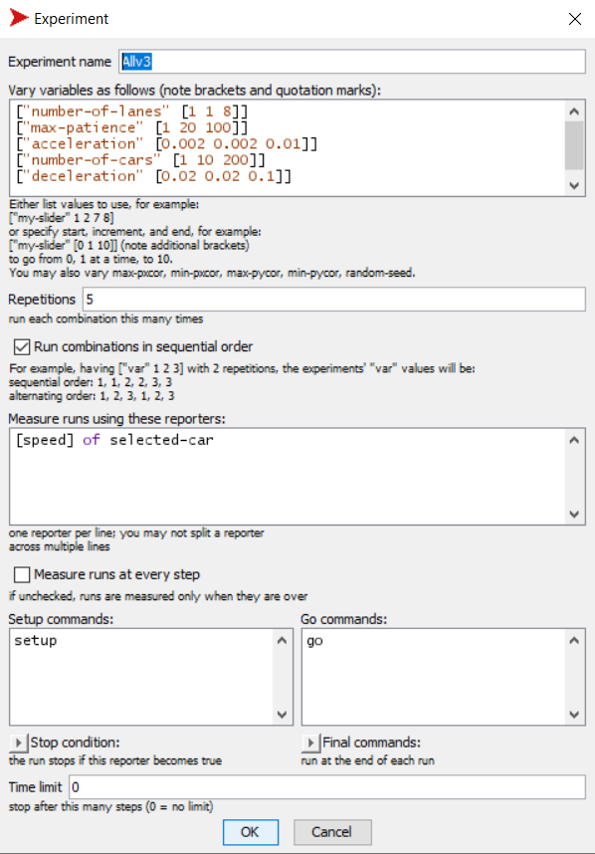

Figure 3: Behavior Space Experiment

In light of the above, we conclude that as the number of lanes increases, the average speed of the cars increases by an average of 4% for each line added with an error of 5%. After further contemplation, this makes sense. If there are, for instance, 2 lanes of road with 50 cars, it may cause traffic, but, if the same number of cars move freely on a road with 8 lanes, the cars will reach their maximum speed and a traffic jam will never occur. Unfortunately, this is not very accurate in the real world, therefore, we need to consider factors other than lanes, such as the patience of the driver, the aggressiveness of the drivers at which they decelerate or accelerate, and the number of cars, in order to have more realistic and accurate results.

## **Hypothesis 2**

The second hypothesis examines any other "invisible" factor other than the increase of traffic lanes, which could play an important role in the solution of the traffic jam. To test this hypothesis, we took the data from hypothesis 1, and we run a linear regression to examine the results.

As we can see from the output below, holding all factors constant, if the number of lanes is increased by 1 unit then the speed of cars will increase by 4.05%. Same holds for acceleration. If the acceleration variable increases by 0.002 units then the speed will jump by 3.22% (0.002 *1608.61%). However, if the number of cars rise by 10 units, then the speed drops by 1.1% (10*0.11%). Same happens with deceleration, where a decrease of 0.02 units results to a 1.81% (0.02 * 90.27%) drop to the speed. Finally, if the max-patience variable was increased by 20 units then the speed decreases by 0.4% (20*0.02%). All variables except max-patience are statistically significant as their p-values are lower than 5% confidence level. Max patience is slightly above 5% (5.8%) which suggests non statistical significance.

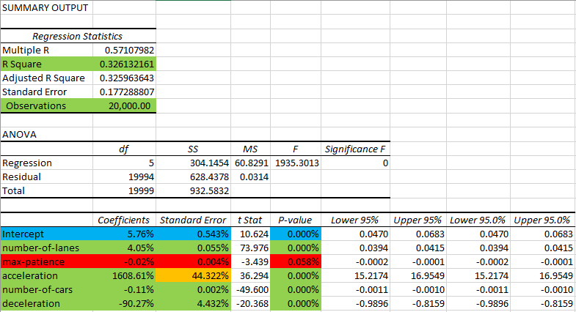

Figure 4: Regressing Speed on 5 Factors

The overall results show that the deceleration variable is crucial to the formation of traffic jams, since in actual life it is common sense that, if even a single car slows down, traffic jams will occur. On the other hand, more lanes and good acceleration will help solve the jam.

# **Statistical Analysis of ABM**

The tables and graphs below are a summary of the data for each variable that shows how the total speed is affected by tweaking these variables separately while the other variables remain at their default value.

## **Number of Lanes**

### **Table 3**

|  |  |  |
| --- | --- | --- |
| **Row Labels** | **Average of [speed] of selected-car** | **StdDev of [speed] of selected-car** |
| 1 | 0.0021024 | 0.016217087 |
| 2 | 0.075903516 | 0.130314508 |
| 3 | 0.122469346 | 0.172010398 |
| 4 | 0.166310749 | 0.202330431 |
| 5 | 0.205592814 | 0.21250273 |
| 6 | 0.244023483 | 0.228592621 |
| 7 | 0.273434839 | 0.236768673 |
| 8 | 0.288990034 | 0.247056296 |

Figure 5: Mean Speed per Lane graph

## **Patience**

### **Table 4**

|  |  |  |
| --- | --- | --- |
| **Patience** | **Average of [speed] of selected-car** | **StdDev of [speed] of selected-car** |
| 1 | 0.180199831 | 0.221421194 |
| 21 | 0.173845591 | 0.217413196 |
| 41 | 0.170422248 | 0.213986262 |
| 61 | 0.170842188 | 0.214878009 |
| 81 | 0.16645713 | 0.211756897 |

Figure 6: Mean Speed per 20 Patience

## **Acceleration**

### **Table 5**

|  |  |  |
| --- | --- | --- |
| **Acceleration** | **Average of [speed] of selected-car** | **StdDev of [speed] of selected-car** |
| 0.002 | 0.101313786 | 0.138704198 |
| 0.004 | 0.143084893 | 0.189815424 |
| 0.006 | 0.17932353 | 0.217361891 |
| 0.008 | 0.208654913 | 0.237604853 |
| 0.01 | 0.229389868 | 0.252403747 |

## **Deceleration**

### **Table 6**

|  |  |  |
| --- | --- | --- |
| **Deceleration** | **Average of [speed] of selected-car** | **StdDev of [speed] of selected-car** |
| 0.02 | 0.219401743 | 0.24410747 |
| 0.04 | 0.18216399 | 0.222355576 |
| 0.06 | 0.163862566 | 0.207636939 |
| 0.08 | 0.152257728 | 0.201346844 |
| 0.1 | 0.144080961 | 0.192182318 |

Figure 7: Mean Speed per 0.02 Deceleration

## **Number of Cars**

### **Table 7**

|  |  |  |
| --- | --- | --- |
| **Number of Cars** | **Average of [speed] of selected-car** | **StdDev of [speed] of selected-car** |
| 1 | 0 | 0 |
| 11 | 0.402292103 | 0.316210464 |
| 21 | 0.34109038 | 0.285427319 |
| 31 | 0.313797667 | 0.269863696 |
| 41 | 0.272400136 | 0.257185776 |
| 51 | 0.251006552 | 0.239523006 |
| 61 | 0.215886241 | 0.218702025 |
| 71 | 0.203269085 | 0.212109342 |
| 81 | 0.172102884 | 0.194409897 |
| 91 | 0.156553195 | 0.179194361 |
| 101 | 0.141170779 | 0.171293089 |
| 111 | 0.137391056 | 0.167562953 |
| 121 | 0.124663605 | 0.152566704 |
| 131 | 0.117515316 | 0.145516675 |
| 141 | 0.11767237 | 0.139657915 |
| 151 | 0.110064131 | 0.136758532 |
| 161 | 0.09953 | 0.133091886 |
| 171 | 0.093246117 | 0.127095016 |
| 181 | 0.09194322 | 0.126343471 |
| 191 | 0.085473114 | 0.112333341 |

Figure 8: Mean Speed per 20 cars

# **Conclusions**

So, what could be done to prevent a traffic jam? Roads can be widened, speed of acceleration with response time increased, and traffic signals can be better synchronized in the future model, and researchers like Google can build driverless cars that travel at more constant speeds. The solution that works is a structurally systematized solution, which is exactly what self-driving cars are. Self-driving cars can only be programmed to stay in the middle and accelerate simultaneously. The solid lane of self-driving cars greatly increases the throughput. After all, a traffic light, for example, is just a tool for drivers on one road to communicate with drivers on the other, poorly and grossly. Red equals "Do not go now, we are going through the intersection" and green equals "Go." On the other hand, self-driving cars can talk to each other at the speed of light, so there is no need for that kind of coordination. Human response time has its limits, and that is the main reason why we need traffic signals for coordination. In addition, based on the underlying traffic simulation, when a broken car has blocked the road to a human driver, the driver will need to light the indicator to send a signal to the other drivers that he wants to switch the lane. It takes a lot of time, and most of the time human drivers are selfish. With self-driving cars communicating with each other at the speed of light, this type of indicator will no longer be necessary, therefore, less or no traffic at all.